**Name: Session:**

**Programming II**

**Lab Exercise 3.12.2021**

1. A Software Company sells three packages, Word Wizard, Calc Master, and The Quickening Accounting Package. Which retail for $99, $199, and $299, respectively. Quantity discounts are given according to the following table.

|  |  |
| --- | --- |
| **Quantity** | **Discount** |
| 10 – 19 | 20% |
| 20 – 49 | 30% |
| 50 – 99 | 40% |
| 100 or more | 50% |

Create an application that allows the user to enter the number of units sold for each software package.

The application should calculate and display the order amounts and grand total. Add a Clear and Exit button to your application.

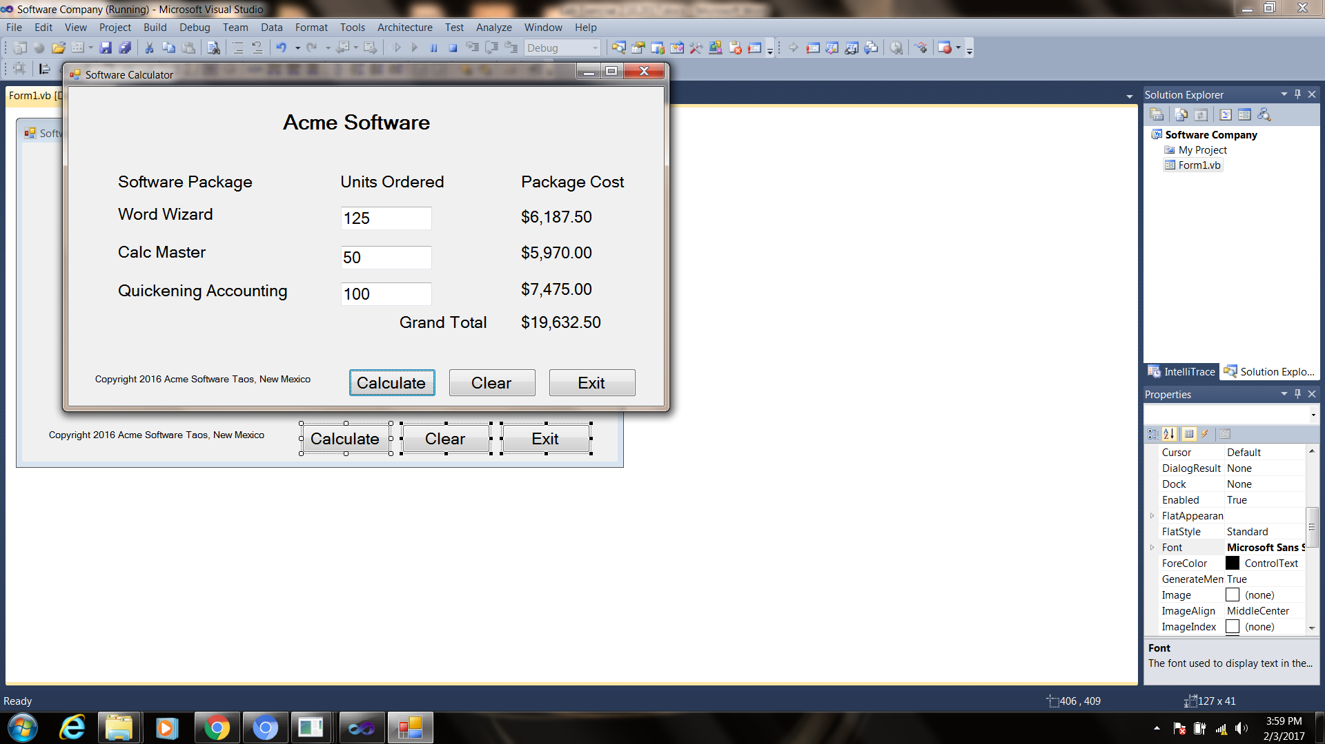

1. An Internet service provider offers three subscription packages to its customers, plus a discount for nonprofit organizations:
2. Package A: 10 hours of access for $9.95/month plus $2.00 for each additional hour.
3. Package B: 20 hours of access for $14.95/month plus $1.00 for each additional hour.
4. Package C: Unlimited access for $19.95/month
5. Nonprofit organizations : 20% discount

The user should select the package the customer has selected from a set of radio buttons and enter the number of hours used. A checkbox captioned Nonprofit Organization should also appear on the form. The application should calculate and display the amount due.

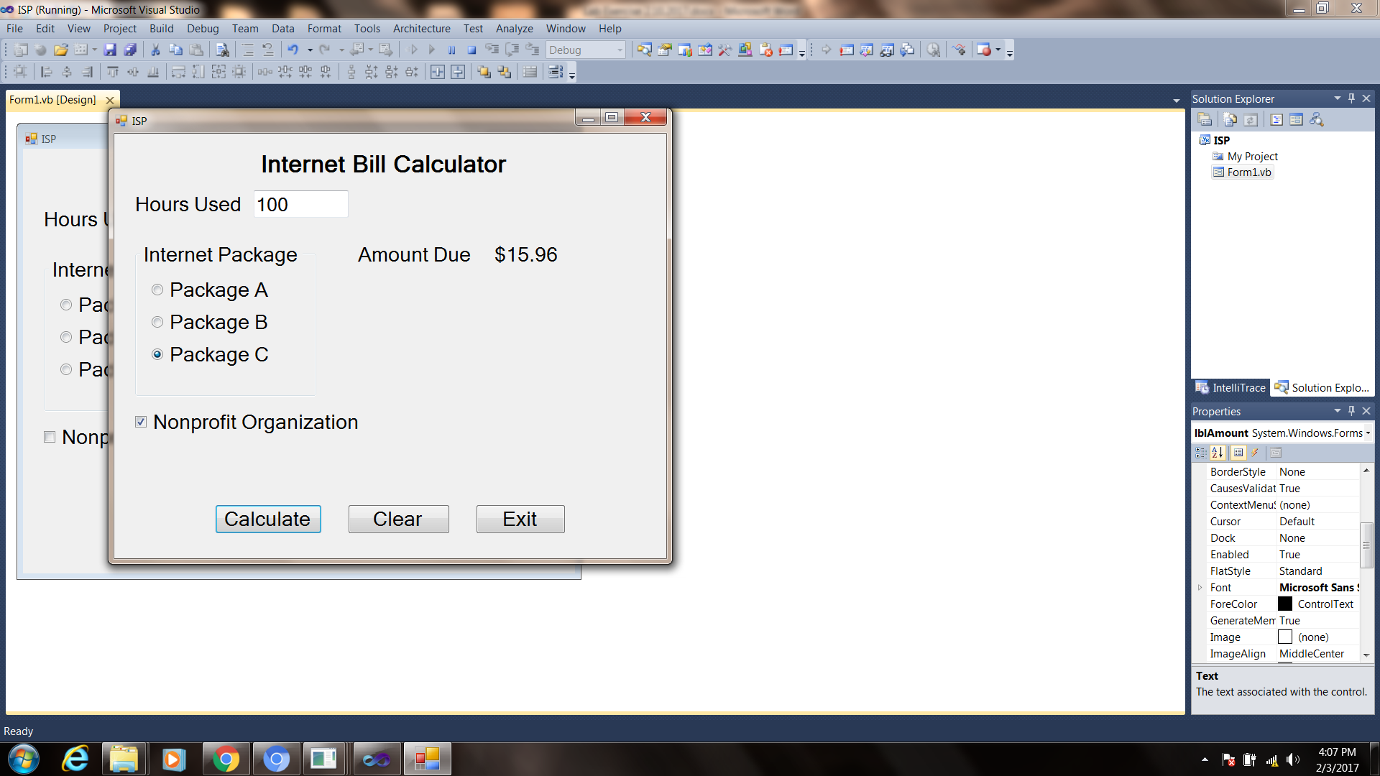

Panel Control

**When you have completed problem 1 and 2, submit their source code and a screen shot of your running applications. Attach these to this sheet and turn in.**